

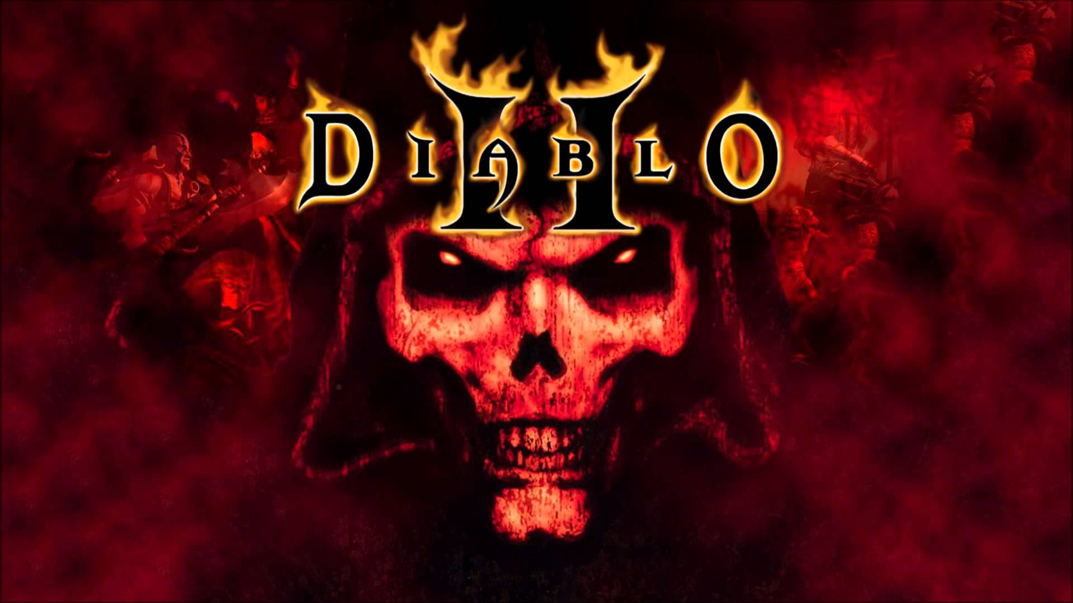

**The Community Guide**

**M.png**

Blood and Gore, Violence

This game has received the following rating from the ESRB

**Table of Contents**

|  |  |  |  |
| --- | --- | --- | --- |
| **Introduction**  The Development  **The Basics**  The Diablo Story  Diablo II and its Expansion  Major Characters  **Classes**  Amazon  Barbarian  Necromancer  Paladin  Sorceress  **The Expansion Classes**  Assassin  Druid  **Popular Builds**  Main Builds  Amazon  Assassin  Barbarian  Druid  Necromancer  Paladin  Sorceress  **Act Quests**  Act I  Act II  Act III  Act IV  Act V  **Bonus Quests**  1.10  1.11  1.13  **The Lists**  Bestiary  Items List  **Multiplayer** | **Credits**  Diablo Series  Classic Team  Blizzard Entertainment  The D2 Community |  |  |

**Introduction**

**The Development**

Diablo is an action role-playing hack and slash video game developed by Blizzard North and the first of its series was released by Blizzard Entertainment on December 31, 1996.

Set in the fictional World of Sanctuary, located in the mortal realm, the Diablo series has the player take control of a lone hero battling to rid the world of the Three Prime Evils.

An expansion pack, entitled Diablo: Hellfire, was released in 1997 by Sierra Entertainment. In 1998, Electronic Arts released Diablo for the PlayStation. This version featured direct control of the main character using the PlayStation controller and was developed by Climax Studios. A Sega Saturn version was also considered by Electronic Arts but never released.

The game's success led to two sequels, Diablo II in 2000, and Diablo III in 2012. To celebrate Diablo's 20th anniversary, the original game was recreated in Diablo III in early 2017.

**The Basics**

**The Diablo Story**

The story of Diablo is based on the premise of a war between Heaven and Hell. The town of Tristram is under attack by hordes of demons, pouring forth from beneath the ruined Tristram Cathedral, and the player must save the town. As the player delves into the network of Dungeons and the Caves beneath the Catacombs, he discovers more about the Demon Diablo, through large tomes that are found throughout the levels. Eventually, the player reaches the lair of Diablo and must kill him.

Diablo, an incredibly powerful demon, is the Lord of Terror and one of the Three Prime Evils of Hell, who had been imprisoned in a Soulstone and buried in caverns deep beneath the town of Tristram centuries ago by an ancient people known as the Horadrim. Though his imprisonment was meant to be eternal, Diablo worked tirelessly to corrupt his Soulstone, eventually overpowering his prison. Diablo received help from the thoroughly corrupt Archbishop Lazarus, who had been turned into his loyal servant. However, in order for Diablo to actually manifest himself in the mortal realm, he needed a mortal vessel to house his spirit.

Diablo first tried to possess King Leoric, the local ruler of Tristram, but due to his weakened state and the strong will of the King, Diablo failed to gain full control. Therefore, the demon abandoned the King, which in turn left the King crazed and senseless. Lazarus then kidnaps King Leoric's younger son, Prince Albrecht. He leads him deep into the Catacombs where he inserts the Demon's Soulstone in the Prince's forehead. This allowed Diablo to possess and warp the prince, thereby attaining material form. Diablo may have a body now, but he is far from his full power, so he bides his time and summons countless hordes of demons, infesting the entire underground complex, gradually turning the region into an outpost of Hell.

The maddened King Leoric accuses the townsfolk of Tristram with the kidnapping of Albrecht, and has several people executed. His loyal knights try to calm him, but as the crazed king has completely lost his sanity they are forced to kill him. His dying words are a terrible curse, damning the knights into unholy servitude. Meanwhile, Lazarus emerged from the catacombs and rallied the townsfolk, leading them deep into the catacombs in order to save the prince. This turns out to be a trap - instead Lazarus leads them to the lair of The Butcher. Many of the townsfolk are slain by the demons. Afterwards Lazarus flees deeper into the underground Dungeon.

Demons appear in the countryside as the Lord of Terror regains his strength in the heart of the labyrinth and prepares for the time when he would once again emerge to seek his brothers - Baal and Mephisto - and free them as well. It seemed to be a matter of time until the Prime Evils gained dominion over the entire mortal realm.

This is where the player comes in. As he or she fights their way through sixteen levels to face Diablo, they encounter various monsters, quests, tomes, scrolls, weapons, and other miscellaneous items.

At the end of the game, the hero removes the soulstone from "Diablo's" head. To the player's surprise, Diablo begins to melt away revealing Prince Albrecht's body underneath. The hero then pierces his or her head with the Soulstone, attempting to contain the Lord of Terror. However, the end of the game hints at a darker outcome. The final scene depicts the hero, swathed in a shadowy, hooded cloak. The closing words are foreboding:

"The Soulstone burns with Hellfire as an eerie red glow blurs your vision. Fresh blood flows into your eyes, and you begin to hear the tormented whispers of the Damned. You have done what you knew must be done. The essence of Diablo is contained for now.

You pray that you have become strong enough to contain the Demon and keep him at bay. Although you have been fortified by your quest, you can still feel him, clawing his way up from the dark recesses of your soul.

Fighting to retain control, your thoughts turn toward the ancient, mystic lands of the Far East. Perhaps there, beyond the desolate wastes of Aranoch, you will find an answer.

Or, perhaps... salvation?"

**The Basics**

**Diablo II and it’s Expansion**

Diablo II's storyline progresses through four chapters or "Acts". Each act follows a more or less predetermined path, although there is some random-level generation in wilderness areas and dungeons between key cities. The player progresses through the story by completing a series of quests within each act, while there are also optional side dungeons for extra monsters and experience.

In contrast to the first Diablo, whose levels consisted of descending deeper and deeper into a Gothic-themed dungeon and Hell, Diablo II's environments are much more varied. Act I is similar to the original Diablo; the Rogue Encampment is a simple palisade fort, while plains and forests making up the wilderness area, and the Monastery resembles the typical Middle Ages fortress. Act II mimics Ancient Egypt's desert and tombs; Lut Gholein resembles a Middle Eastern city and palace during the Crusades. Act III is supposedly based on the Central American jungles; Kurast is inspired by the lost Maya civilization. Act IV takes place in Hell and is the shortest, with just three quests compared to the other Acts that have six.

The Lord of Destruction expansion adds the fifth chapter Act V which continues the story where Act IV left off. Act V's style is mainly mountainous as the player ascends Mount Arreat, with alpine plateaus and ice tunnels/caverns, as well as hellish subterranean pits (reminiscent of Hell in Act IV) for extra monsters and experience. After reaching the summit of Arreat, the player gains access to the Worldstone Keep (whose architecture may be reminiscent of Angkor Wat and other Hindu temples)

In addition to the acts, there are three sequential difficulty levels: Normal, Nightmare, and Hell; completing the game (four Acts in the original or five Acts in the expansion) on a difficulty setting will open up the next level. On higher difficulties, monsters are stronger and may be resistant or immune to an element or physical damage, experience is penalized on dying, and the player's resistances are handicapped. However, better items are rewarded to players as they go through higher difficulties. A character retains all abilities and items between difficulties, and may return to a lower difficulty at any time.

Players can create a hardcore character. In normal mode, the player can resurrect their character if killed and resume playing, while a hardcore character has only one life. If killed, the character is permanently dead and unplayable, and all items and equipment on that character will be lost unless another friendly character has the "loot" icon checked.

**The Basics**

**Major Characters**

These are the major characters in the Diablo II storyline, as outlined by the game’s designers from Blizzard North. This is not a detailed listing of each character’s motivations and personality, but rather, is merely meant to tell you a little about each character so you can identify where they ‘fall’ in the plot as you work your way through the game

Andariel

 Lesser Evil. Maiden of Anguish

Baal

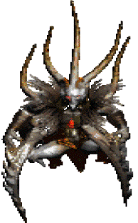The last of the Prime Evils. Brother of Diablo. Lord of Destruction

Diablo

Prime Evil. Lord of Terror

Duriel

Lesser Evil. Prince of Pain

Izual

Angel. Bore the rune blade “ Azure Wrath” in an assault on the Hell Forge and was corrupted. First gave the demons information about the soulstones. Now serves as a Lieutenant in Hell

Jered Cain

Horadric Leader that pursued and captured Diablo

Mephisto

Prime Evil. Lord of Hatred

Tal Rasha

Tal Rasha was a powerful Horadric mage and leader of the Horadrim who sacrificed himself to forever encapsulate Baal in the dunes of Aranoch in the Tomb of Tal Rasha.

Tyrael

 He was the one who provided the Horadrim with the soulstones they used to imprison Diablo, Mephisto, and Baal with centuries before the time covered in Diablo and Diablo II, and he has appeared to humans in many other times and locations.

**Classes**

**Amazon**

 The Amazon is a powerful woman warrior of the Askari, who belongs to nomadic bands who roam the plains near the South Sea. The wandering of these groups often brings them into conflict with other peoples, so the Amazon is accustomed to fighting to defend her own. This lifestyle has made her fiercely independent and able to weather severe hardship and travel. While her skill with the Bow rivals that of the Rogues, the Amazon is also adept in the use of Spears and Javelins, as well as in hand to hand combat. Amazon Weapons are items which only Amazons can equip. These are special Bows, Javelins and Spears. The Amazon is much sought after as a mercenary, in which type of service she will be loyal as long as her own ends are also served.

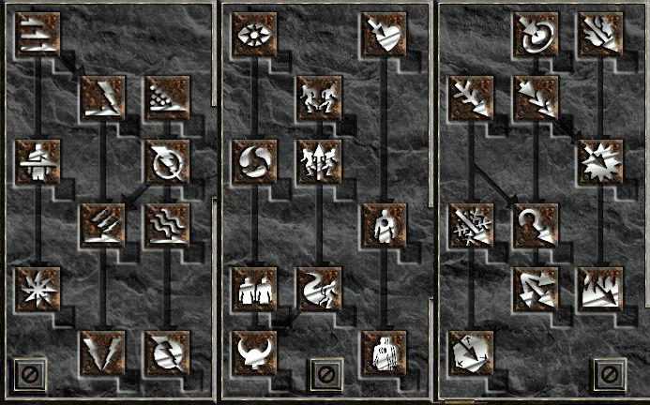

Specializations

|  |  |  |
| --- | --- | --- |
| Bow and Crossbow Skills | Passive and Magic Skills | Javelin and Spear Skills |
| 1. Magic Arrow 2. Fire Arrow 3. Cold Arrow 4. Multiple Shot 5. Exploding Arrow 6. Ice Arrow 7. Guided Arrow 8. Immolation Arrow 9. Strafe 10. Freezing Arrow | 1. Inner Sight 2. Critical Strike 3. Dodge 4. Slow Missiles 5. Avoid 6. Penetrate 7. Decoy 8. Evade 9. Valkyrie 10. Pierce | 1. Jab 2. Power Strike 3. Poison Javelin 4. Impale 5. Lightning Bolt 6. Charged Strike 7. Plague Javelin 8. Fend 9. Lightning Strike 10. Lightning Fury |

Amazon Bow and Crossbow Skills

These skills modify the arrows or bolts fired in magical ways; splitting them into numerous shots, making them home in on a moving target, adding elemental damage, and so forth.

Bows vs. Crossbows:

Bows fire more quickly than crossbows, but do less damage. Bows have always been much more popular (aside from the Guided Arrow bug and the Buriza during v1.09), chiefly since firing quickly is such a useful and fun talent, but it's possible to play successfully with a bow or crossbow. Bows are slightly more convenient since arrow quivers hold 350 arrows, while bolt quivers hold only 250 bolts.

Magic Arrow

Required Level: 1

Prerequisites: None.

Synergies: None.

Details: This is truly a magic arrow; fired without taking one from the quiver. It can therefore be fired when you are entirely out of arrows or bolts, and is helpful if you need to finish up a few last enemies before returning to town or scavenging for more ammo. There is also a bonus to attack rating and damage.

Magic Arrow can not be used with any of the other skills in this tree.

Since v1.09 this skill has enjoyed the added bonus of converting some % of physical damage to magical damage, thus making it useful against physical immune or resistant monsters.

This damage is taken from the total shot damage, after bonuses from the bow, dexterity, charms, etc, are calculated.

Lore: Far in the ancient past, Amazons found their glorious arboreal city of Tran Athulua under siege by the pirates of the Twin Sea. These cut-throats were determined to turn the Amazon Islands into their base of operations. The conflict lasted many months as the pirates laid in for a long siege. During the battle, supplies ran short, and the Amazon archers found themselves without ammunition. Realizing that their defense rested solely upon the ability of the archers to keep the corsairs at bay, the priests of the city prayed to Athulua to aid them. In answer, Athula infused the minds of the Amazons with the power to harness their natural spiritual energies. One by one the archers melded their determination and will into shards of physical force that they then unleashed from their bows by the thousands, firmly routing the corsairs back to sea.

Fire Arrow

Required Level: 1

Prerequisites: None.

Synergies: Points in the following skills boost the effect of Fire Arrow.

Exploding Arrow: +12% Fire Damage Per Level.

Details: Fire damage is added to the regular physical damage of the arrow, along with an accuracy bonus. Exploding Arrow and Immolation Arrow add much more fire damage, and this skill was purely a prerequisite, until some improvements were added in v1.09.Since the v1.09 patch, Fire Arrow has worked somewhat like Magic Arrow, in that it converts a % of physical damage to fire damage. This damage is taken from the total shot damage, after bonuses from the bow, dexterity, charms, etc, are calculated.

There is still physical damage, some % of it simply counts as fire. For example, with level 2 Fire Arrow and a 1000 damage arrow, 5%, or 50 points of damage would register as fire, while 95% or 950 points, registered as physical. The small fire damage bonus of this skill adds onto that.

Lore: Hefaetrus is the Amazonian god of fire and rebirth who lives deep within the great volcano, Mount Arnazeus, on the island of Philios. Although primarily the patron deity of farmers, from time to time he bestows his favours upon the warriors of the Islands, so they may keep safe his congregation. Through proper prayer and the sacrifice of many fierce enemies, an especially brave Amazon can attain the power to imbue her shots with the destructive power of fire, allowing her to rake blazing missiles from her bow.

Cold Arrow

Required Level: 6

Prerequisites: None.

Synergies: Points in the following skills boost the effect of Cold Arrow.

Ice Arrow: +12% Cold Damage Per Level.

Details: Adds cold damage to a normal arrow shot. This skill will chill and slow monsters, and adds a bonus to accuracy as well.

Since the v1.09 patch, Cold Arrow has worked like Fire Arrow, in that it converts a % of physical damage to cold damage. This damage is taken from the total shot damage, after bonuses from the bow, dexterity, charms, etc, are calculated.

There is still physical damage, some % of it simply counts as cold. For example, with level 2 Cold Arrow and a 1000 damage arrow, 5%, or 50 points of damage would register as cold, while 95% or 950 points, registered as physical. The small cold damage bonus of this skill adds onto that as well.

Lore: Although winter never seems to find its way to the ever-balmy Amazon Islands, cold climates are not unheard of. The summit of Mount Karcheus on the island of Philios is covered with snow all year long. Deep within an icy cave secluded amongst its towering peaks, is the Great Hall of Mirrors where mighty Karcheus the Watcher sits upon his throne. Ever vigilant, Karcheus keeps watch over the people of the Amazons. Warriors who have trained within his temple are able to instill their shots with the power of a freezing wind.

Multiple Shot

Required Level: 6

Prerequisites: Magic Arrow

Synergies: None.

Details: Each fire arrow or bolt splits into multiple shots. This skill gives the largest potential damage in the skill tree, since each arrow can strike multiple targets, and so many can be fired so quickly.

Only one arrow from each Multiple Shot can hit a given target; you can't get up close and fire 15 shots at once into the same enemy, so per shot/per target, this skill does the least damage of any skill in the tree. Its power comes from the ability to hit numerous enemies with each shot.

The spread of the arrows is determined by how far from the Amazon the cursor is pointing when the skill is used. Aim next to the Amazon for a very wide spread. Aim near the edge of the screen for a tighter cluster.

Lore: Legend has it that the fabled Amazon archer, Palashia, bragged in her youth that she could best the combined skills of all her greatest rivals. Taking umbrage, her rivals gathered to challenge her outrageous boast, arranging a contest to decide the question. To preserve her honor, Palashia was to strike the targets of all her rivals before they could land a single arrow. When dawn arose on the day of the contest, Palashia stood ready with her bow. At the signal, her rivals nocked their arrows and loosed a volley towards their targets. Palashia gathered her energies, and let fly with her own, single arrow. To the amazement of onlookers, her arrow split into many, cleaving the arrows of her rivals, and moving on to strike every target directly in their centers. This mysterious technique quickly became a martial secret that only the finest archers are able to master.

Exploding Arrow

Required Level: 12

Prerequisites: Multiple Shot, Fire Arrow

Synergies: Points in the following skills boost the effect of Exploding Arrow.

Fire Arrow: +12% Fire Damage Per Level.

Details: Enchants arrows by adding explosive fire damage to them. The flame splashes enough to strike several monsters in a tight cluster, and there is an accuracy bonus as well.

Lore: Another gift of Hefaetrus, an Amazon warrior practiced in this skill can imbue the arrows that she fires with the ability to explode upon impact. The resulting detonation not only allows her to damage her intended target, but also anything caught within the explosive blast. The sight of a full battalion of Amazon archers firing a volley of such arrows is eerily beautiful. Many warriors, having witnessed good friends consumed by the flames of these arrows, vow never to fight against Amazon warriors ever again.

Ice Arrow

Required Level: 18

Prerequisites: Cold Arrow

Synergies: Points in the following skills boost the effect of Ice Arrow.

Cold Arrow: +8% Cold Damage Per Level

Freezing Arrow: +5% Cold Length Per Level

Details: An upgrade to cold arrow, this skill freezes targets instead of just chilling them, and adds more cold damage and attack rating as well.

This skill does not convert any of the physical damage to cold, and is therefore largely useless in comparison to Cold Arrow, since v1.09.

Other players, bosses, and SuperUniques can not be frozen, and will be chilled instead.

Freeze times are cut by 1/2 in Nightmare and 3/4 in Hell.

Lore:The second of the prizes Karcheus bestows to a true warrior, this skill enables the Amazon to instil her arrows with the glacial force of a fierce blizzard. Enemies struck by this power not only feel the icy sting of the enchanted shaft, but also the force of a chilling Arctic wind that, mysteriously, they alone can feel.

Guided Arrow

Required Level: 18

Prerequisites: Magic Arrow, Cold Arrow, Multiple Shot

Synergies: None.

Details: Guided Arrows will seek a target, changing direction and pursuing an enemy well off the visible screen. This skill adds considerable damage at higher levels, and since it always hits (bypassing defense, though it can still be blocked) it can be the best choice to kill very high defense monsters, such as Diablo and Baal.

If you do not target a monster directly, the Guided Arrows will seek the target nearest the cursor when you shoot.

Prior to v1.09 this was the best single target arrow skill, since Piercing worked with it, and allowed each arrow to hit the same target multiple times. This was a bug and no longer functions.

Guided arrows select a target based on the Amazon's line of sight. If a monster is behind a wall or other obstacle and could not be hit with a straight shot, the Guided Arrow will not acquire it, even if you aim to the side of the wall. (This sucks.)

This skill is very handy to finish off running targets, such as leapers, teleporting bosses, or other players in PVP, since once locked on, you can continue firing at them even if they are well off your visible screen.

Lore: Hunting and fighting during the night and in the deepest darkness is a necessary skill to any daughter of the Amazon islands. Devoted disciples of Athulua can, with great difficulty and strict discipline, train themselves to fire their arrows at targets blindly, as if the hand of Athulua herself guided the arrows. As might be imagined, this is an art that the Sisters of the Sightless Eye have long envied and yet have never replicated.

Immolation Arrow

Casting Delay: 1 Second

Required Level: 24

Prerequisites: Magic Arrow, Fire Arrow, Multiple Shot, Exploding Arrow

Synergies: This skill is boosted by points in the following skills

Fire Arrow: +5% Average Fire Damage Per Second Per Level

Exploding Arrow: +10% Average Fire Damage Per Level

Details: Adds fire damage and creates a small firewall upon impact, dealing additional fire damage to any monsters who stand in or pass through the flames.

The fire damage isn't high enough to make this viable in Hell, or in larger games, but it can be a lot of fun playing solo.

Pierce works very well with Immolation Arrow, especially in narrow hallways such as the Maggot Hive.

With the casting delay, it's best to alternate some other arrow skill between Immolation Arrow shots. It can be paired nicely with Guided Arrow or Strafe, to help leech back enough mana.

Lore: Hefaetrus will sometimes bestow this ability to his greatest champions. These fire-instilled arrows burn with such a fierce intensity that the very earth surrounding where they impact ignites into flame. Although the fires last but a few moments, some say the effect is as if the pillars of the mighty Kingdom of Hefaetrus were reaching up through the ground to strike down the enemies who linger nearby.

Strafe

Required Level: 24

Prerequisites: Magic Arrow, Multiple Shot, Cold Arrow, Guided Arrow

Synergies: None.

Details: Strafe can turn the Amazon into a machine gun, allowing her to fire a stream of shots from a single arrow. Since the Guided Arrow/Pierce bug was fixed in v1.09, Strafe is the best single-target skill in most situations.

Use Strafe on single targets, a few targets, or numerous monsters in a tight cluster. Each arrow does more damage than Multishot, and can hit multiple targets with Pierce.

Post v1.09, high level Strafe fires all 10 arrows every time, regardless of how many targets are in range. This makes it very useful against the last few monsters in a given pack, especially if they are spread out so a single Multishot could not hit them all.

Strafe benefits greatly from Increased Attack Speed. See tables and frame breaks for that here.

While firing Strafe the Amazon can not move until all the arrows have been fired. This could be quite dangerous in earlier versions of D2, when 20 or more arrows could be fired, but now that the number is capped at 10 it's not such a consideration.

Lore: Once a warrior has attained this facility, she can fire a volley of arrows with amazing speed and precision, striking one target after another. Veteran mercenaries often tell a tale of a new recruit who was nearly struck down in battle because he was too distracted when first seeing an Amazon use this ability. Do not doubt his word, as he is probably referring to himself. Just smile and buy him another tankard of ale.

Freezing Arrow

Required Level: 30

Prerequisites: Cold Arrow, Ice Arrow

Synergies: None.

Details: Adds an explosive cold blast to a arrow or bolt, freezing the target and splashing several yards to the sides, potentially freezing adjacent enemies as well.

The cold damage adds to the arrow's regular physical damage.

This cold damage is not sufficient to quickly kill physical immunes late in the game. Fire Arrow and Cold Arrow are more effective for that with their ability to convert physical damage to elemental damage, if you have a big damage bow.

Other players, bosses and Super Uniques cannot be frozen, and will be chilled by this skill.

Cold and frozen durations are 1/2 in Nightmare and 1/4 in Hell. Cold times stack from various items though, so with some charms and other mods Freezing Arrow can remain useful in Hell.

Lore: The greatest of the powers attained by those dedicated to Karcheus is the skill to imbue their arrows with the freezing power of a devastating avalanche. Enemies within the impact of a freezing arrow are frozen in their tracks and feel crushing pain, as if a mass of magical ice had toppled onto them.